Infra Assessment

1]Create a domain named **Gold. local** and Join the Windows client to the domain you created. Verify if you can login from the client using a non- admin domain user. Also install **Additional Domain Controller (ADC)**

->Add roles and features from dashboard

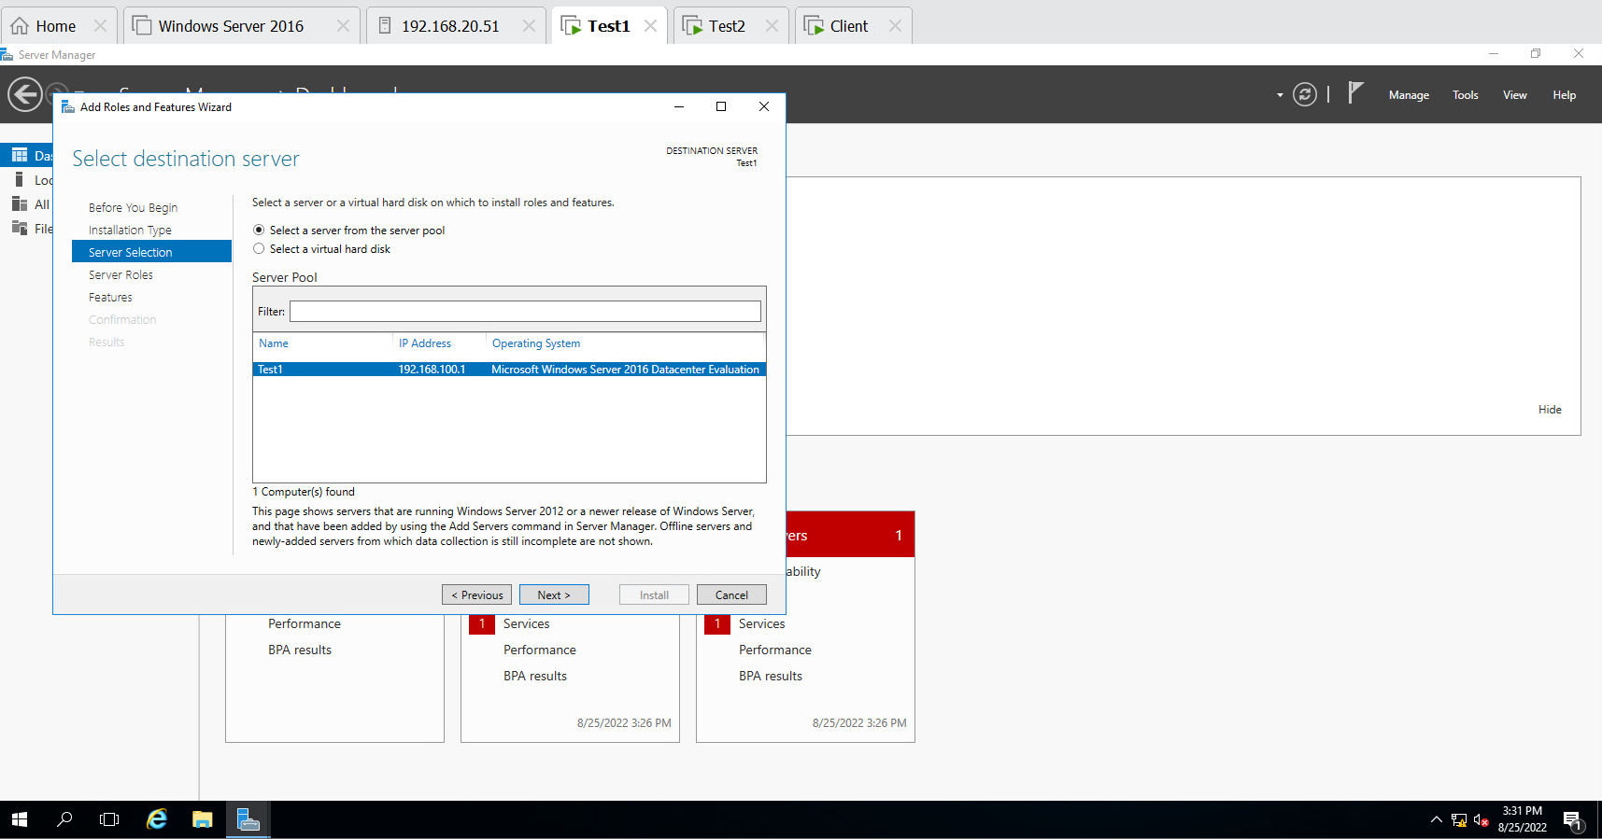

Add roles and feature and then click on Active directory domain services

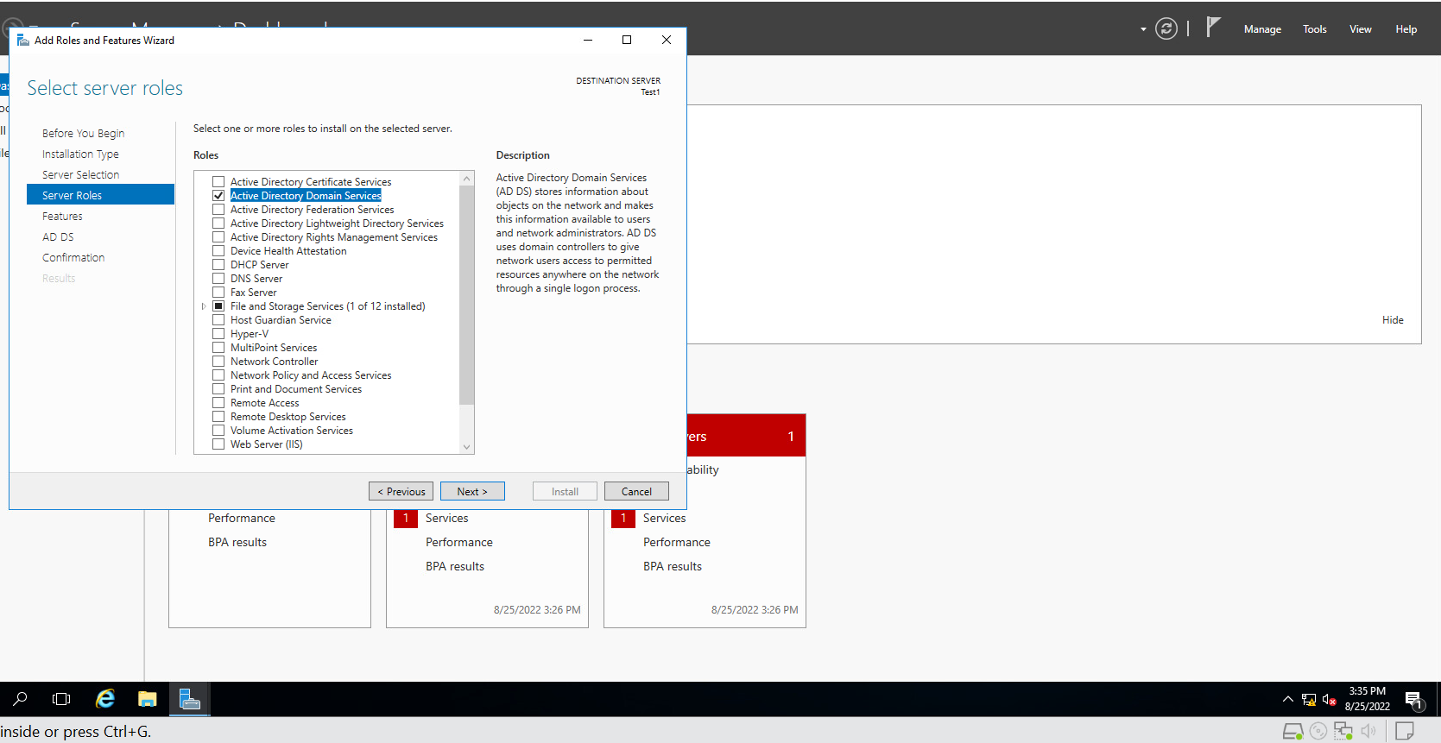

Make new forest and named it gold and refresh it….

And do same for server 2 which is our (Test2)…… add domain name same what we named in test1

And then add on the existing forest in test2 then it is connected to our test1.

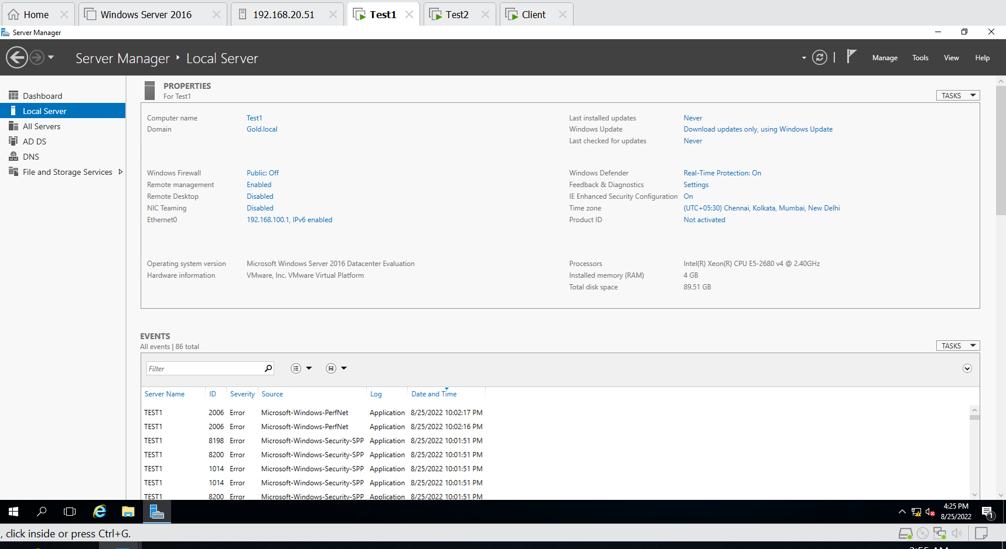

2]Perform all tasks related to DNS including all types of DNS records creation, Create Forward Lookup Zone, Create Reverse lookup zone. Display the current DNS Cache, Clear the current DNS Cache. Verify if all records are getting resolved from the Client OS.

Created Forward lookup zone and reverse lookup zone and then checked its working or not in client Cmd with writing both name and address.

Displaying the DNS Cache………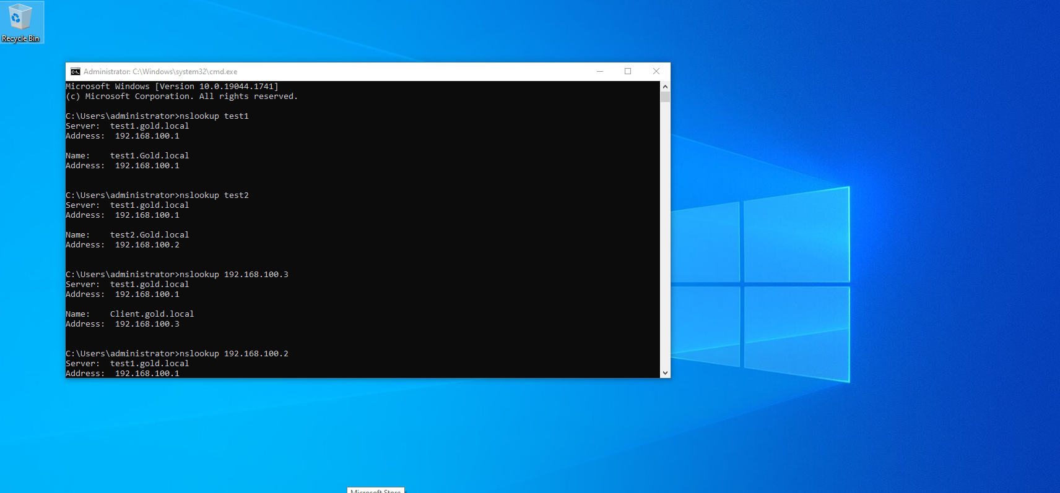 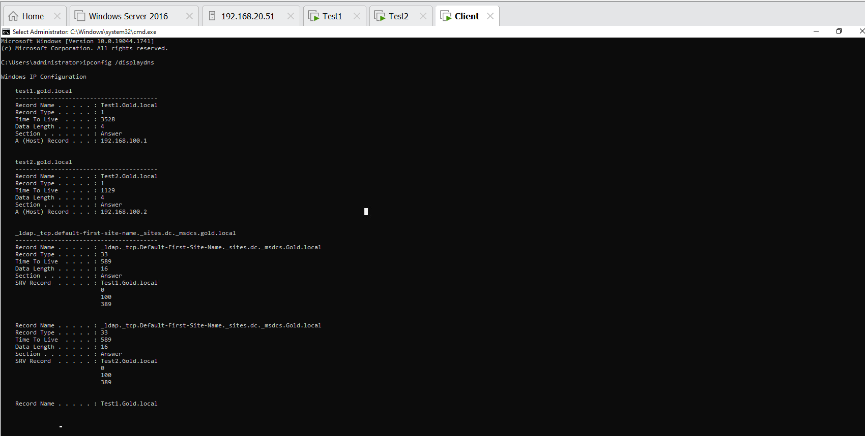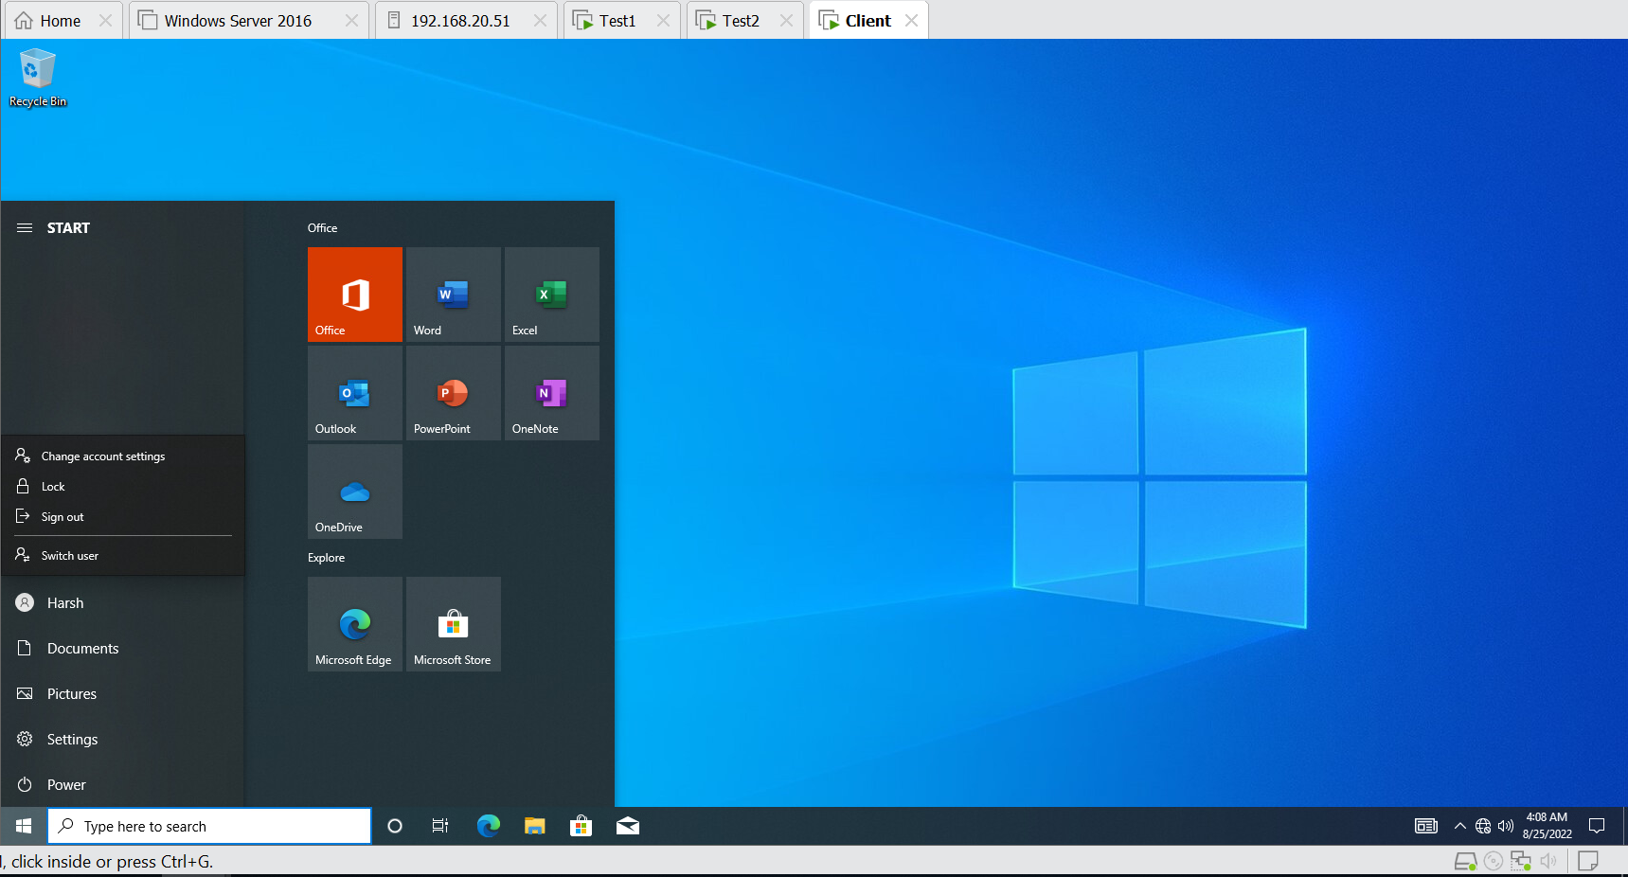

Clearing the DNS Cache

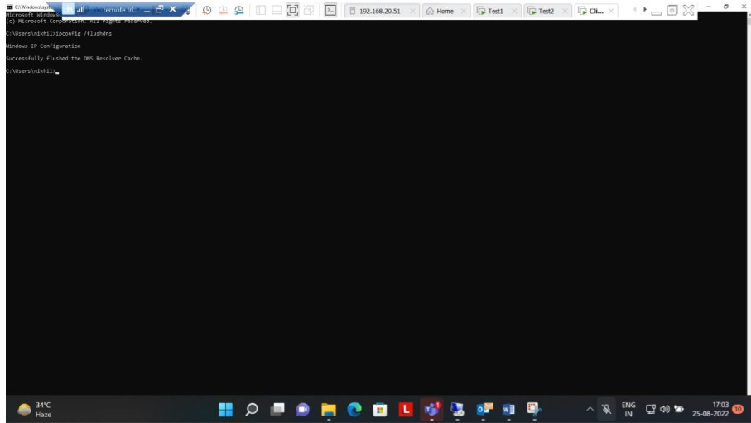

3]Clients should get dynamic IP address every 5 hours. Scope 192.168.100.100 to 192.168.100.200 and exclude starting and Ending IP address

Installing the DHCP …………………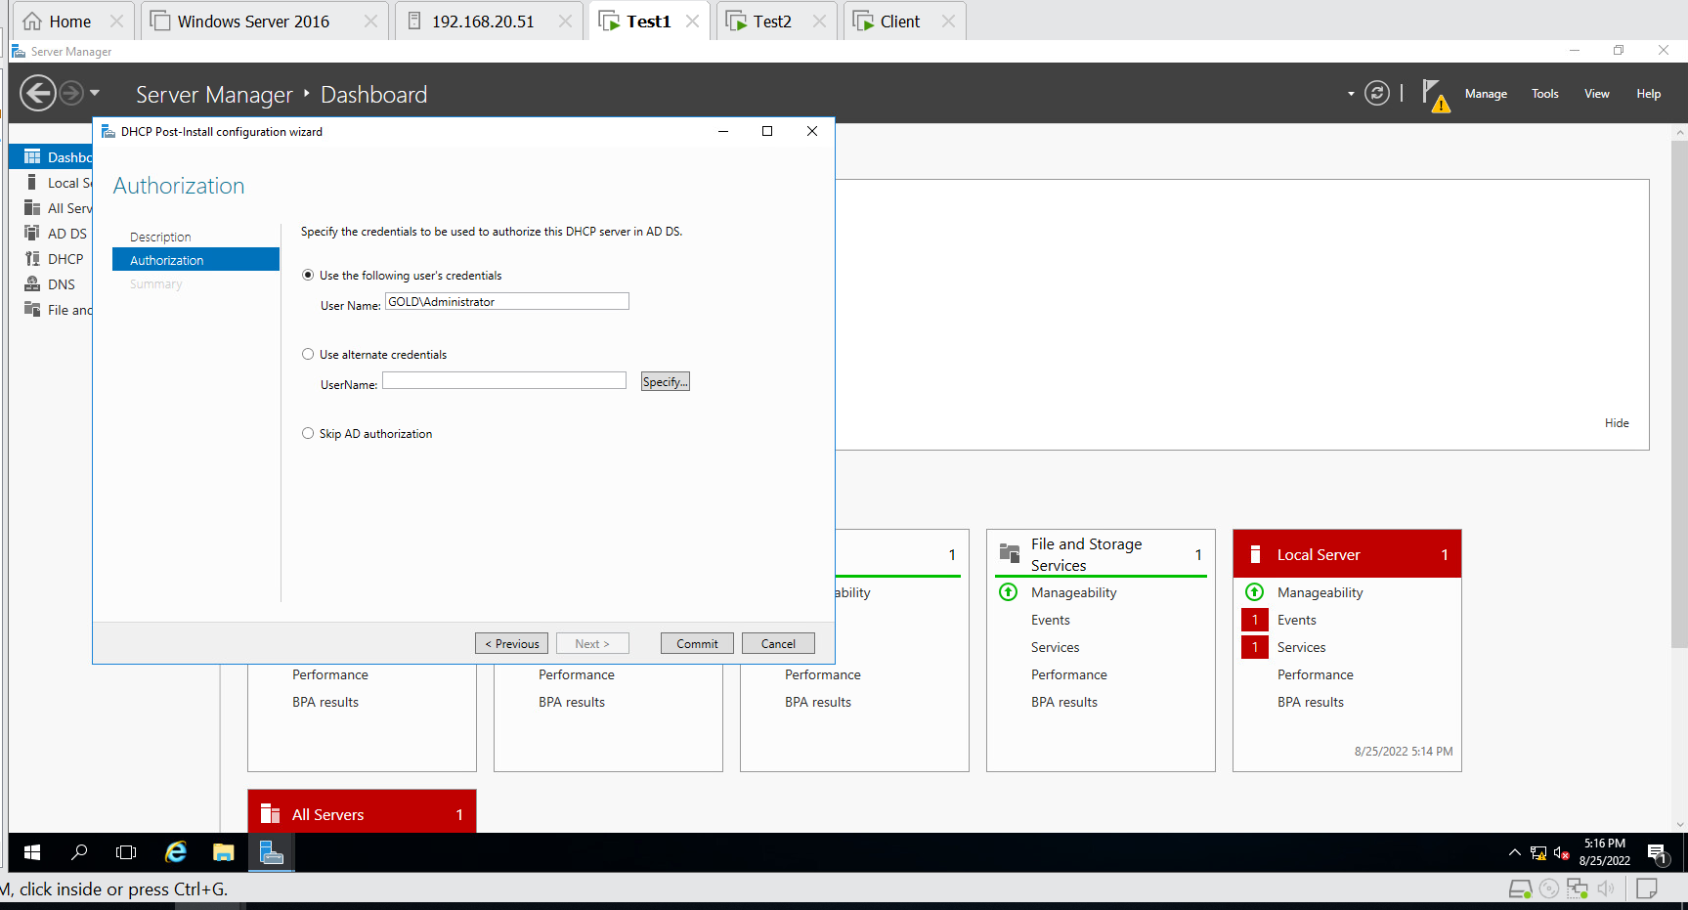

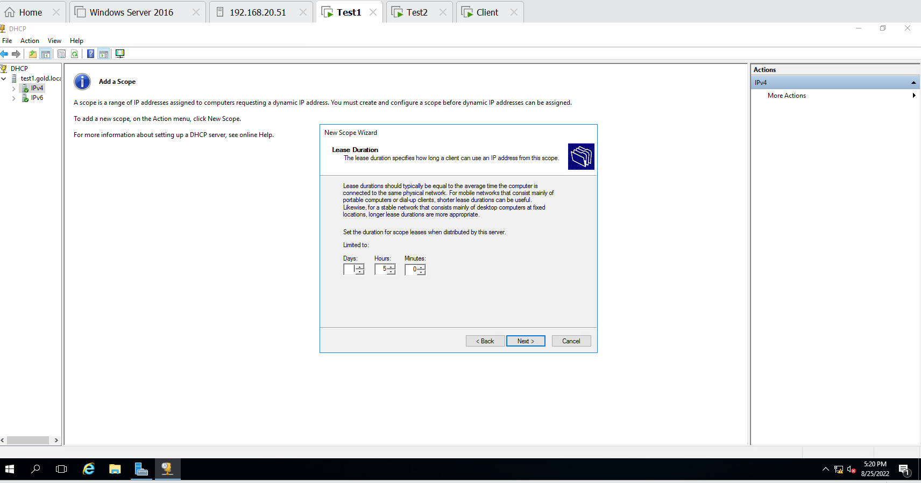

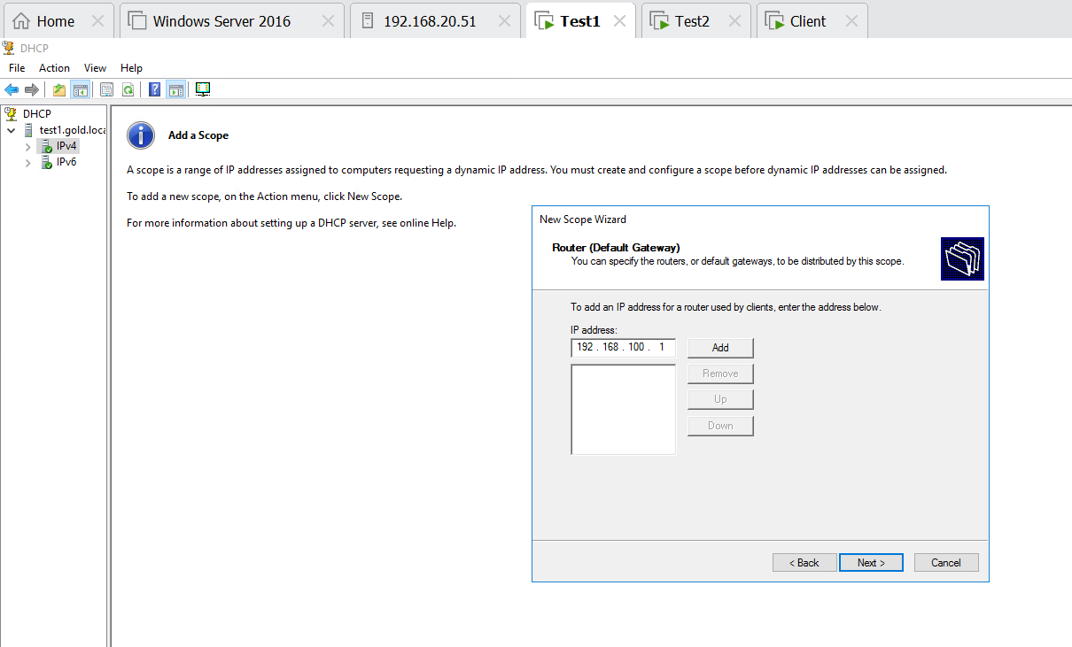

Our Excluded IP Address……..

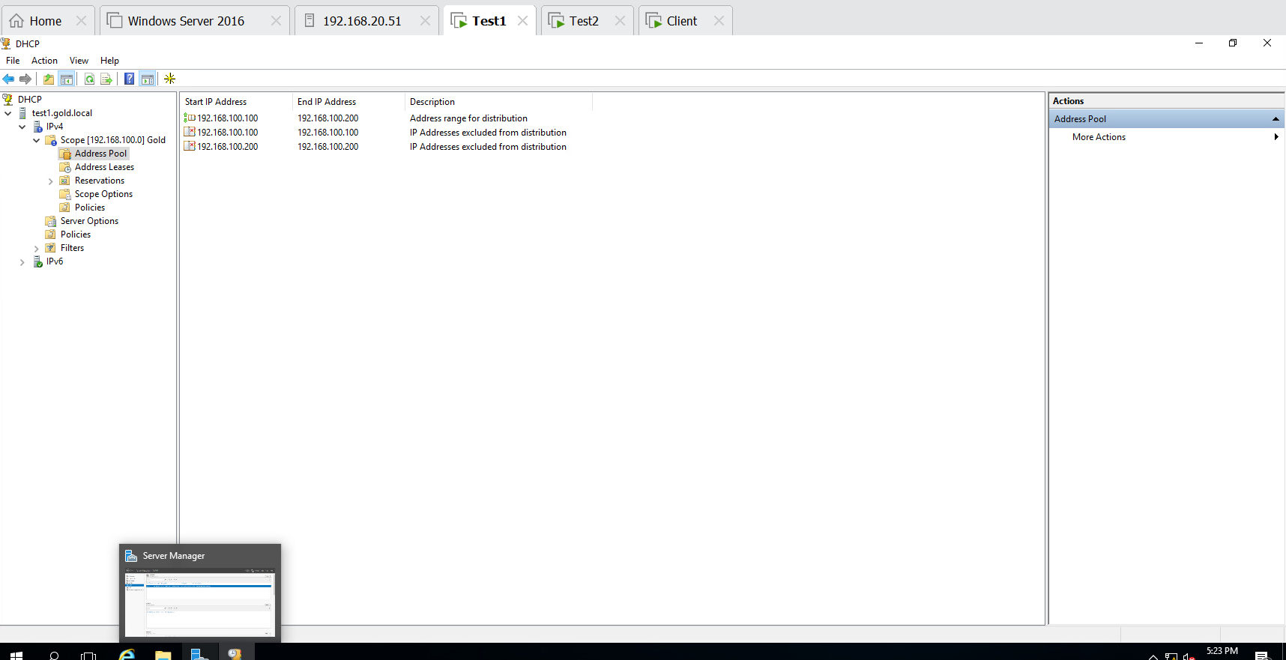

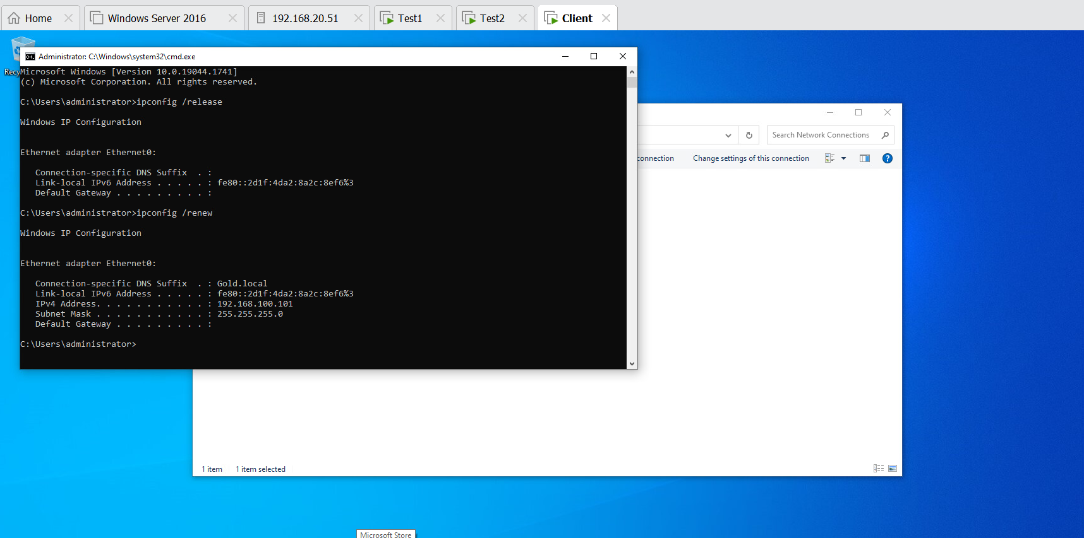

4]Create below mentioned OU’s and users, groups. Group members are from own OU. (8marks)

